Premiere BioARTCAMP Video Installation at WAAG Society 21 06 201

A Rocky Mountain Expedition in Art and Biology
A Co Production of G-Netwerk & INCUBATOR
Jeanette Groenendaal, Zoot Derks and Jennifer Willet
English Subtitles
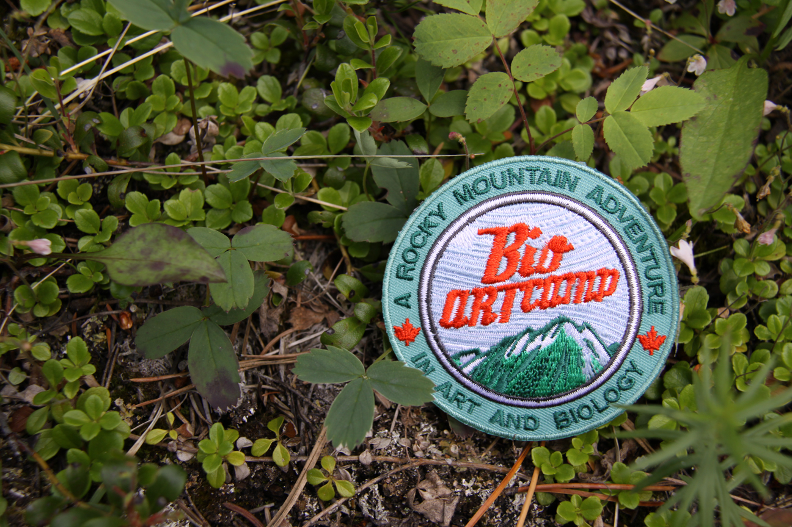
BioARTCAMP was a camping expedition where 20 international artists, scientists, filmmakers, and students worked to build a portable bioart laboratory in Banff National Park. BioARTCAMP served as a “field research station” housing a biotechnology lab and avant garde art installation in the same tent.
BioARTCAMP serves to provide audiences an alternative vision of the biotech future (a humorous and self-critical vision) – an ecological vision of our relations and responsibilities to the other life forms we share our planet and our laboratories with.

BioARTCAMP was a two-week residency program at The Banff Centre of the Arts
directed by Dr. Jennifer Willet from INCUBATOR Art Lab at The University of Windsor, Canada.

The BioARTCAMP video installation loops 11 short videos across three screens following artists
and scientists through their BioARTCAMP experiences.
We see their triumphs – failures –exhaustion – and dynamic art and science discoveries through the quixotic lens of Dutch video Artists Jeanette Groenendaal and Zoot Derks.

The resulting installation is a crescendo of different BioARTCAMP personalities each wearing a brightly colored orange vest – capturing the complexity and the calamity what actually occurred when Jennifer Willet brought a variety of artists, and scientists, and specimens, and lab equipment together under a big tent in the Canadian Rocky Mountains!
Premiere BioARTCAMP Video Installation at WAAG Society 21 06 2013

LOOP Screen A
* Trailer BIOARTCAMP (16 min)

Screen B1)
Scientists (60.20 minutes)
* Dr. Bulent Mutus Professor of Biochemistry at University of Windsor (16. 30min)
* Kurt Illerbrun PhD Candidate in Ecology, University of Alberta (17.30 min)
* Iain Baxter& (and Louise Baxter&) Artist, Professor Emeritus, University of Windsor (12.30 min)
* Angus Leech Musician, Artist, Writer, Interaction Designer Researcher Producer (14.30 min)

Screen B2)
Artists (61 minutes)
* Paul Vanouse Artist, Professor of Visual Studies, University of Buffalo, Co- Director Emerging Practices MFA (30.30 min)
* Tagny Duff Interdisciplinary Artist , Researcher, Educator and Independent Curator (19.30min)
* Marta de Menezes PhD student University of Leiden, Artist, Director of Ectopia- and Cultivamos Cultura (11.30 min)

Screen B3)
Context/ Production/ Philosophy (56.03 minutes)
* Dr Jennifer Willet Director of INCUBATOR, School of Visual Arts, University of Windsor (24.30)
* Dr Melenti Pandilovski, Director and Curator of Video Pool Winnipeg (13 min)
* Marie Pier Boucher PHD Art Art History and Visual Studies Duke University. (19 min)

Credits: Video Installation Direction Jeanette Groenendaal and Zoot Derks
Interviews, Camera, Edit, Subtitling; Jeanette Groenendaal and Zoot Derks
Music: Angus Leech and Dylan Leech, Audio Post Production: Warning Studio’s
Credits: BioARTCAMP Project Designer and Project Director: Jennifer Willet Project Manager: Tokio Webster
Credits Participants:Iain Baxter&, Angus Leech, Tagny Duff, Paul Vanouse, Marta De Menezes, Marie Pier Boucher,Kurt Illerbrun, Bulent Mutus, Jeanette Groenendaal, Zoot Derks, Jennifer Willet, Jamie Ferguson, Britt Wray, Kacie Auffret, David Dowhaniuk]
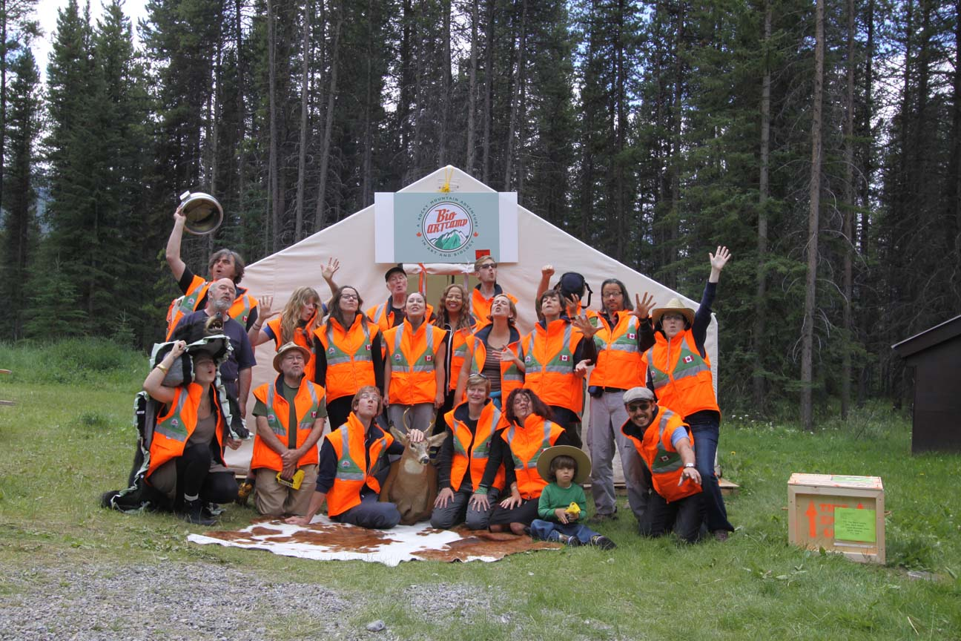

We are grateful for support from the following partners:
The Banff Centre fro The Arts, The University of Windsor, SSHRC the Social Sciences and Humanities Research Council of Canada, The Ontario Arts Council, Hostelling International , Glenbow Museum, The Art and Genomics Centre, at The University of Leiden, Fonds BKVB,

www.G-netwerk.nl
www. waag.org
//incubatorartlab.com

